**Computer Architecture HW2 Report**

*Bubble sort & Quick sort By SPIM*

EE3 B03901156 Yu Xuan Huang

1. Bubble Sort

Design:

First, I divide the whole program into three parts completed by the respective function, including

a. To get array’s size and input integers from users.

b. To bubble sort the input array.

c. To output the sorted array.

The core of the design is according to the c++ pseudo code on the below:

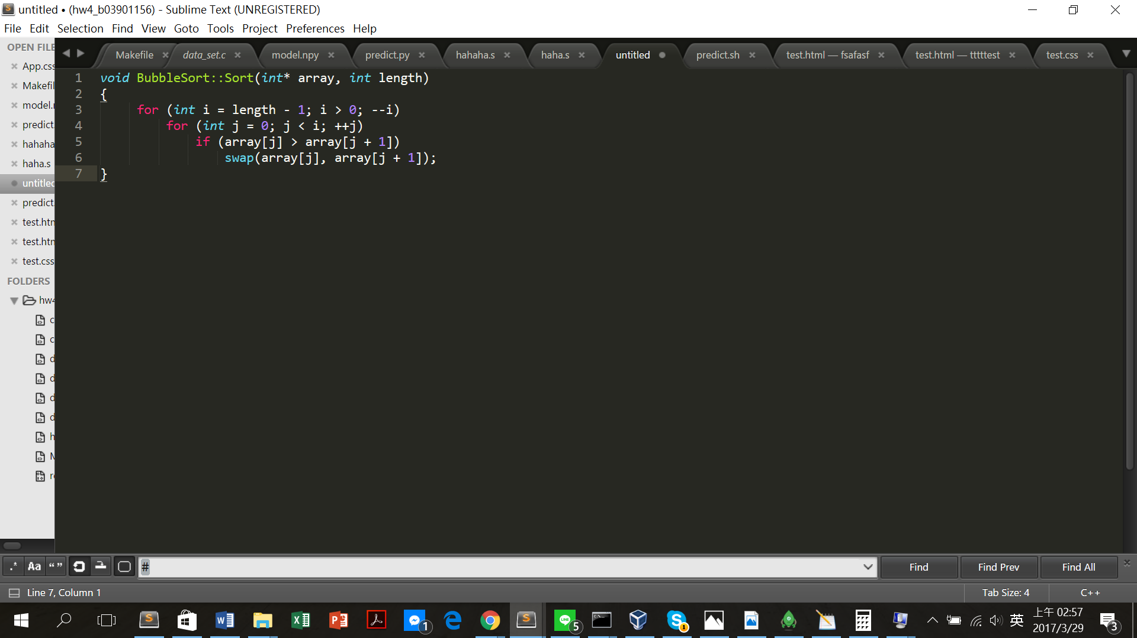

And all the required explanations are illlustrated as comments in the source code on the below:

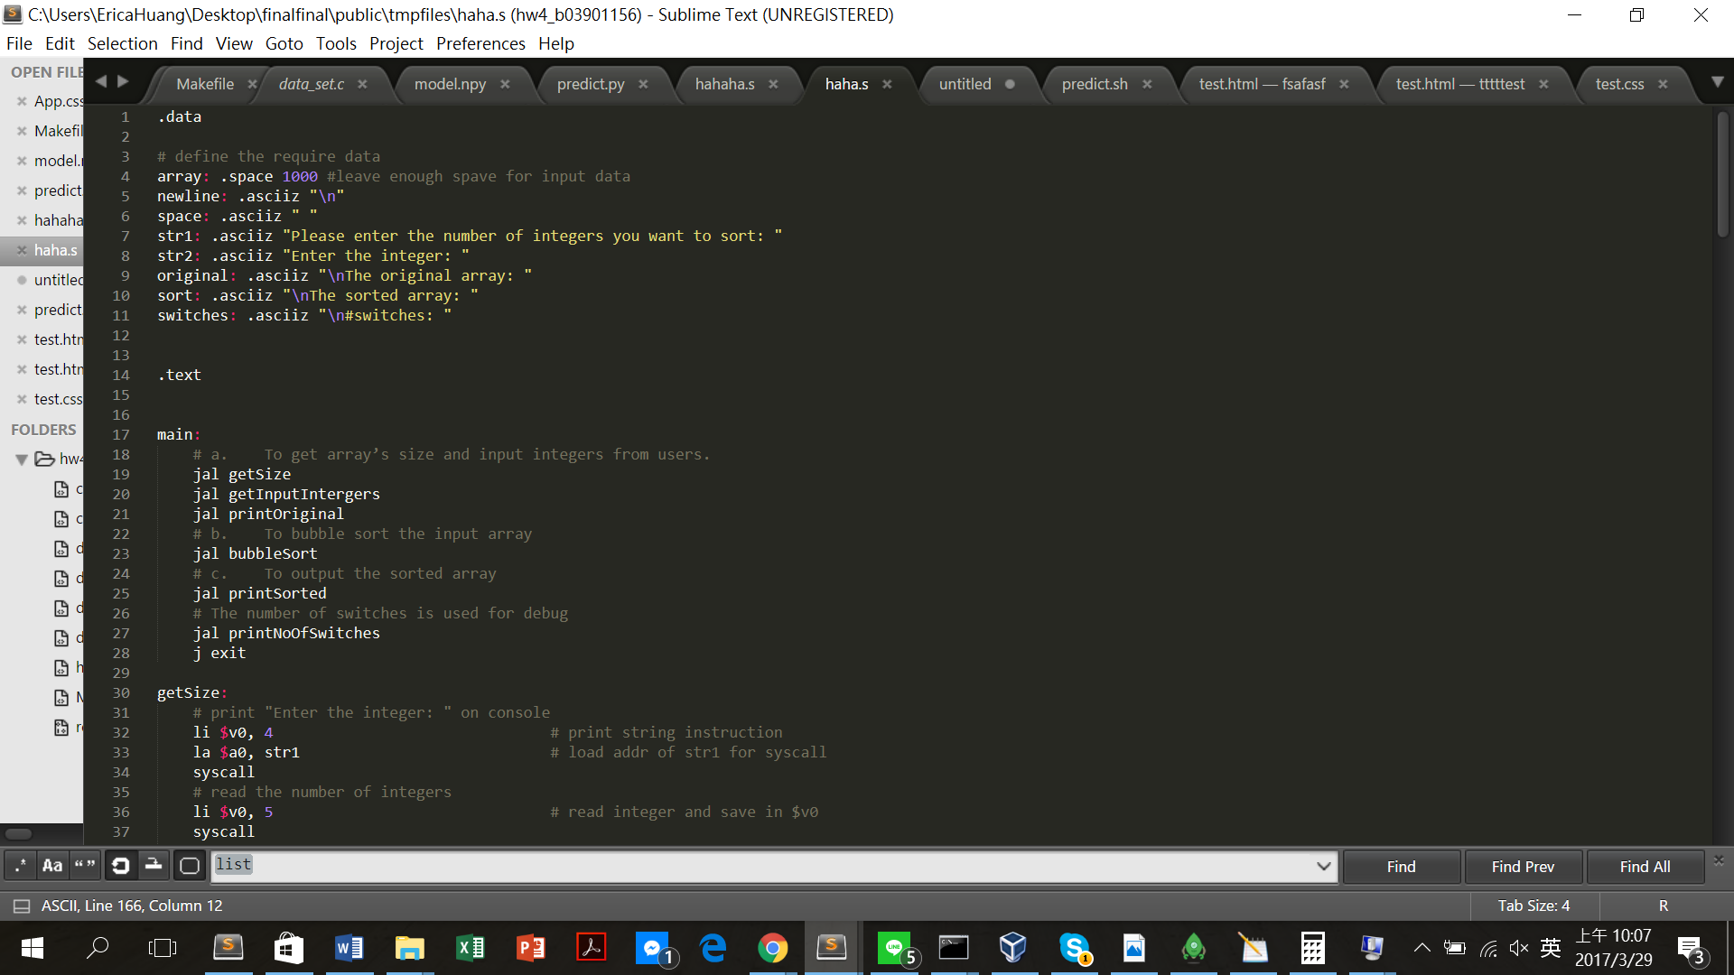

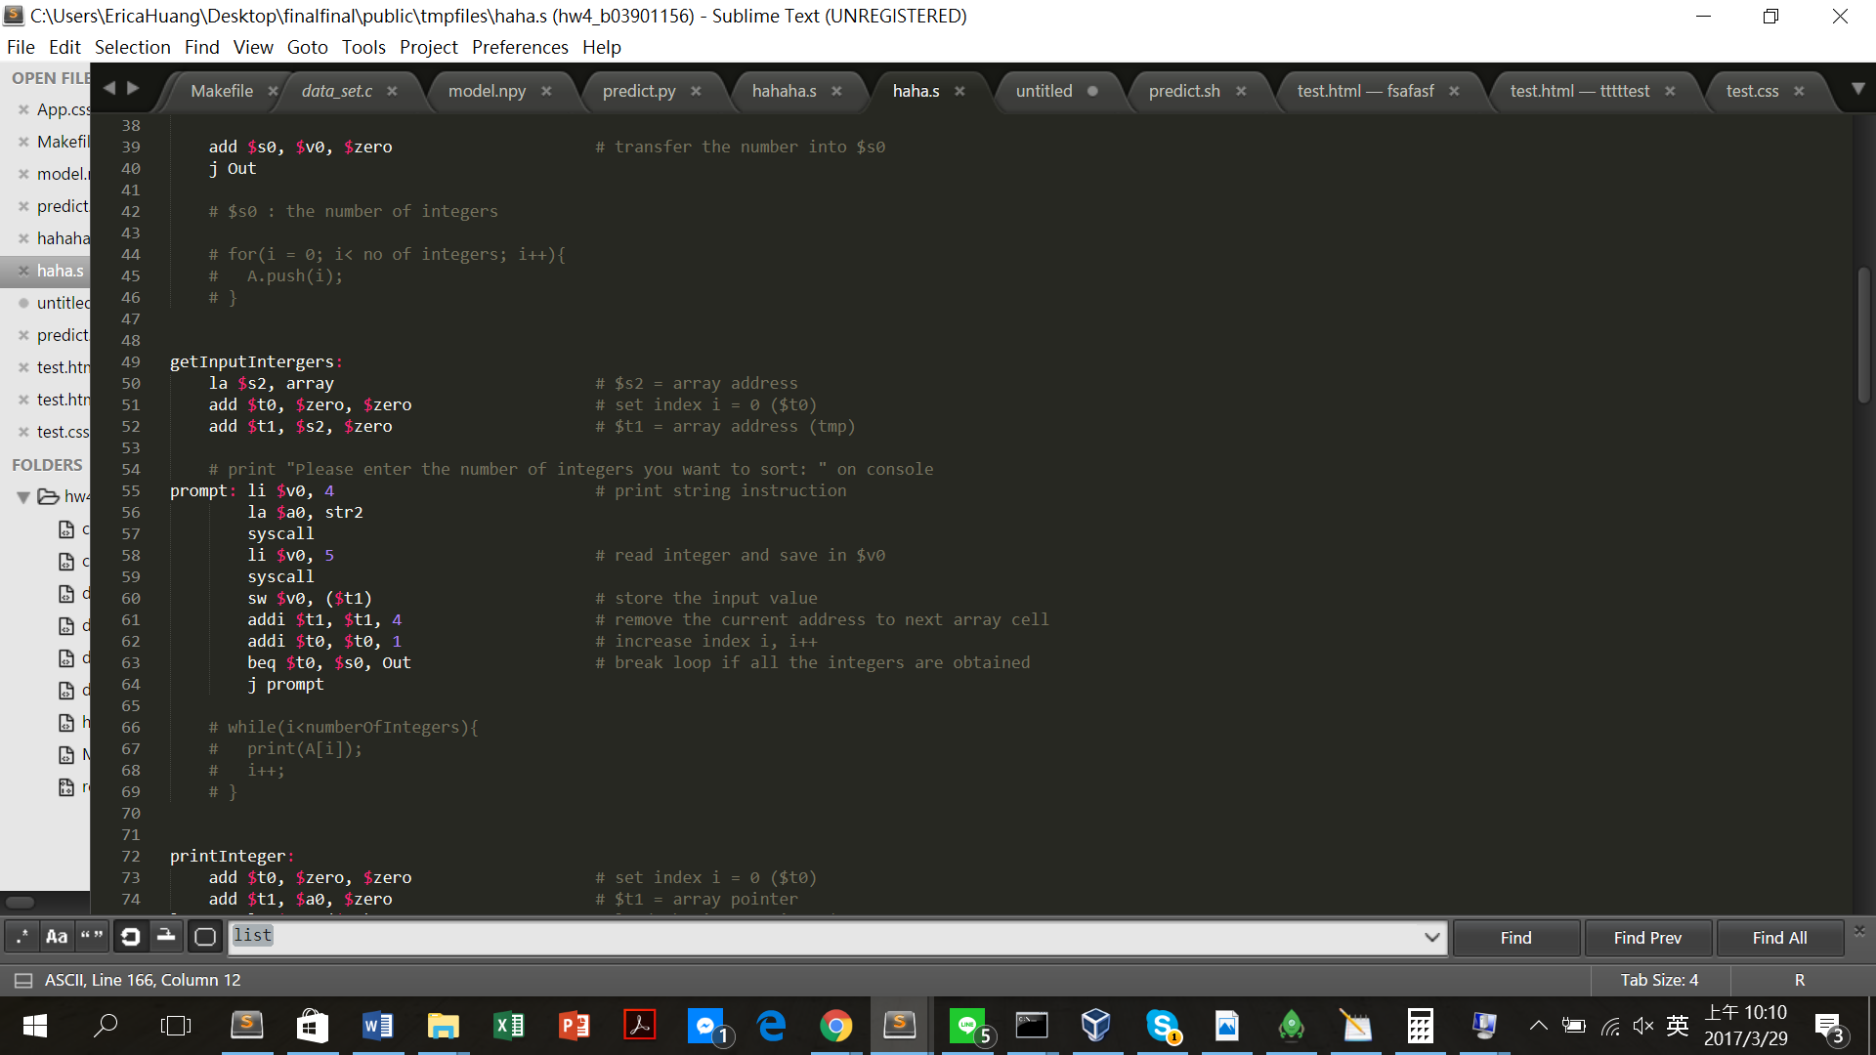

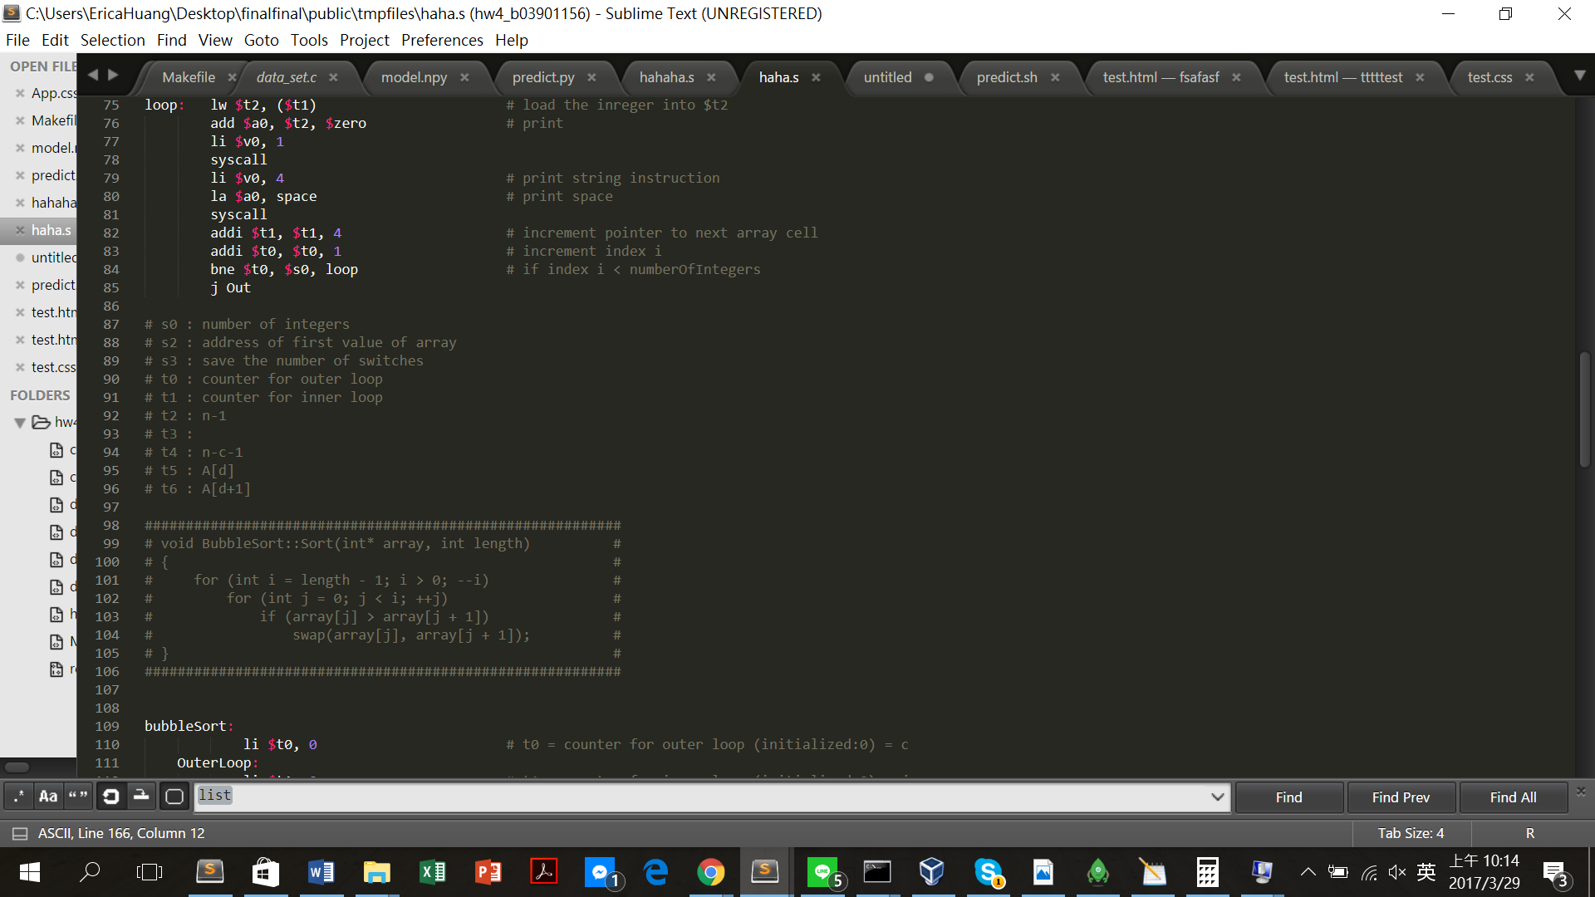

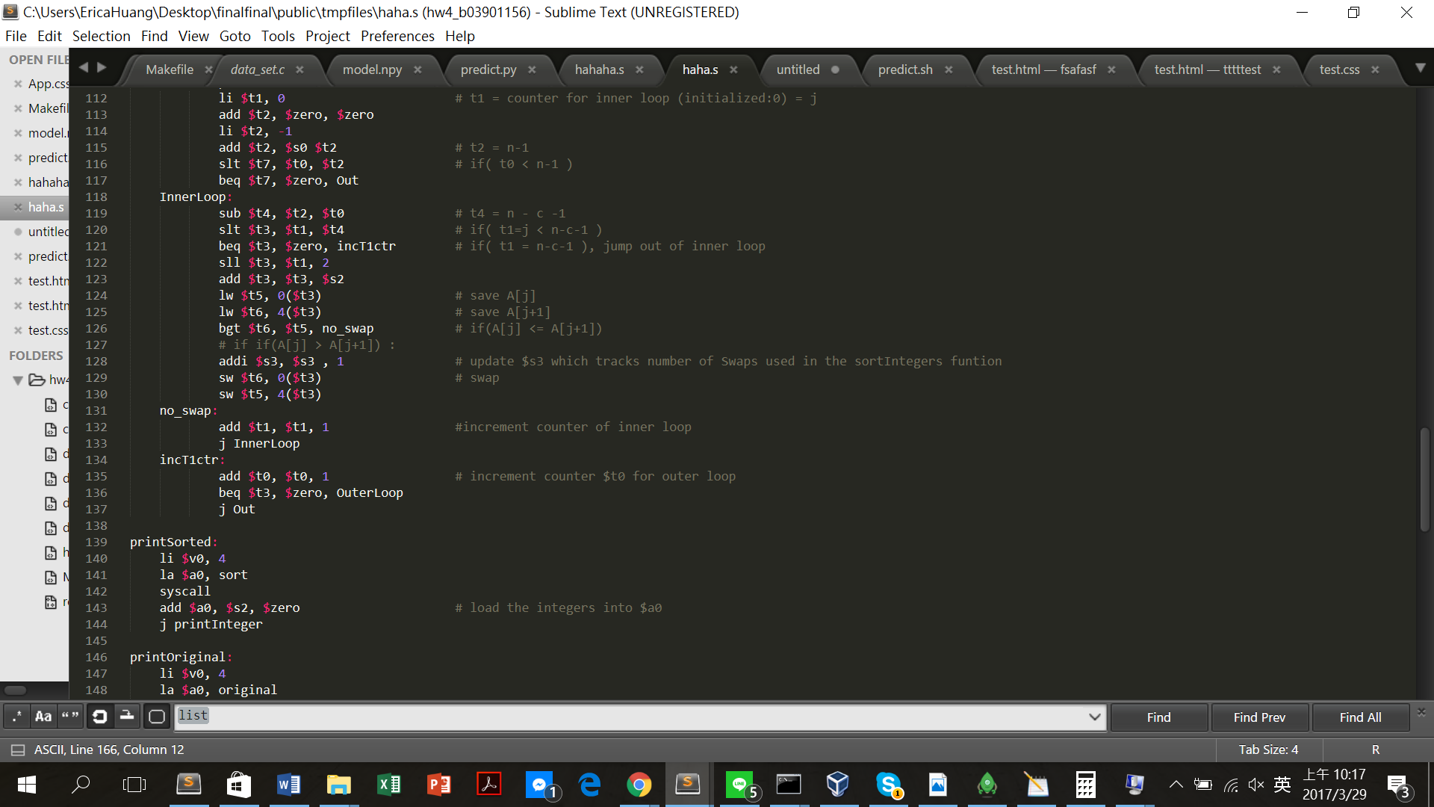

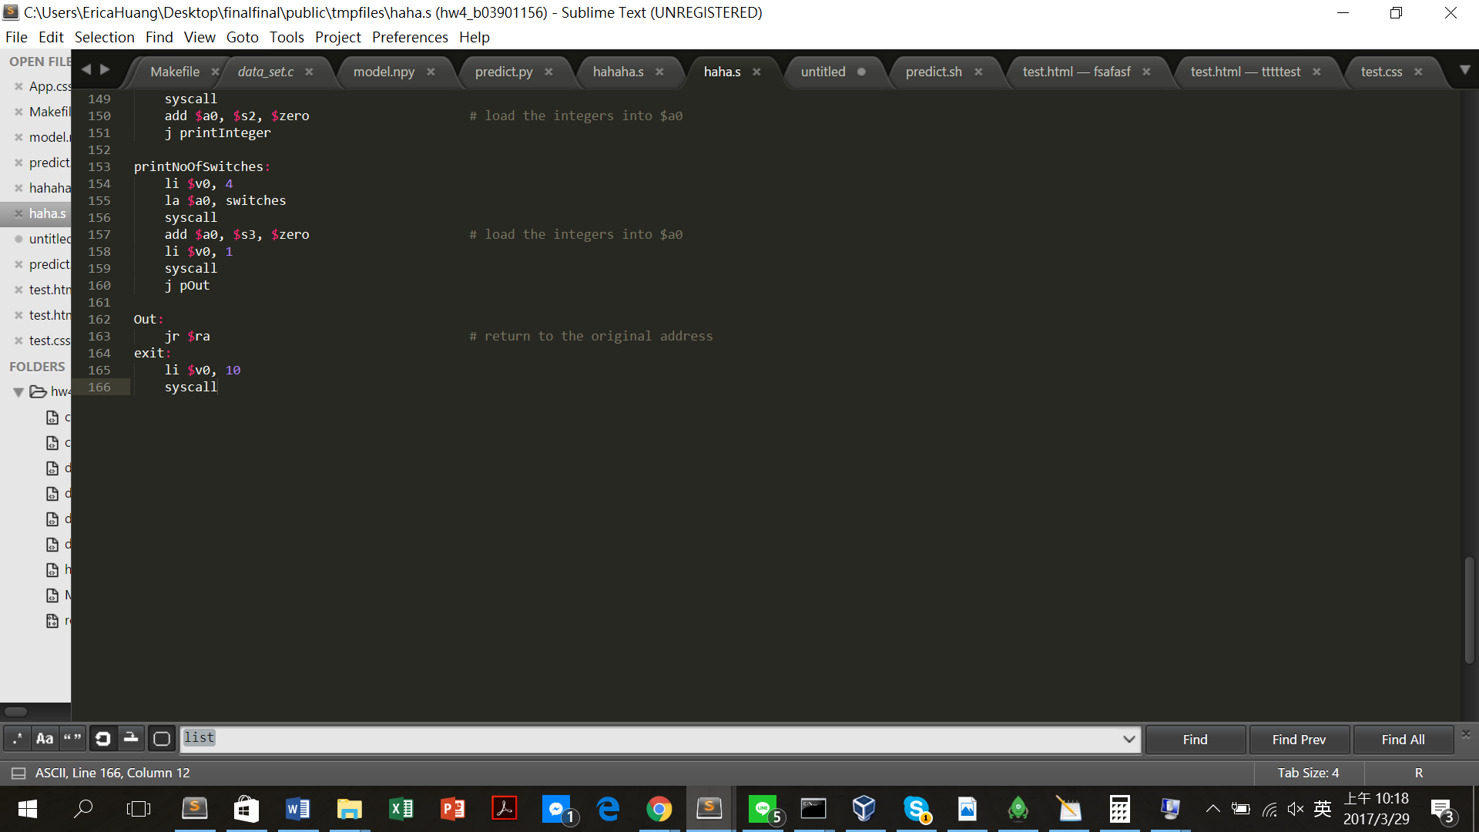

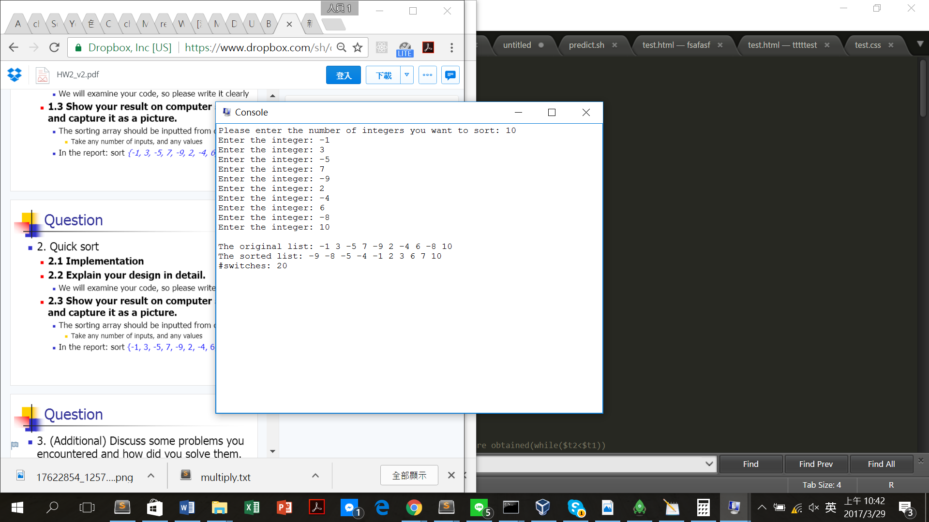Result:

1. Quick Sort

Design:

First, I divide the whole program into three parts completed by the respective function, including

a. To get array’s size and input integers from users.

b. To quick sort the input array.

c. To output the sorted array.

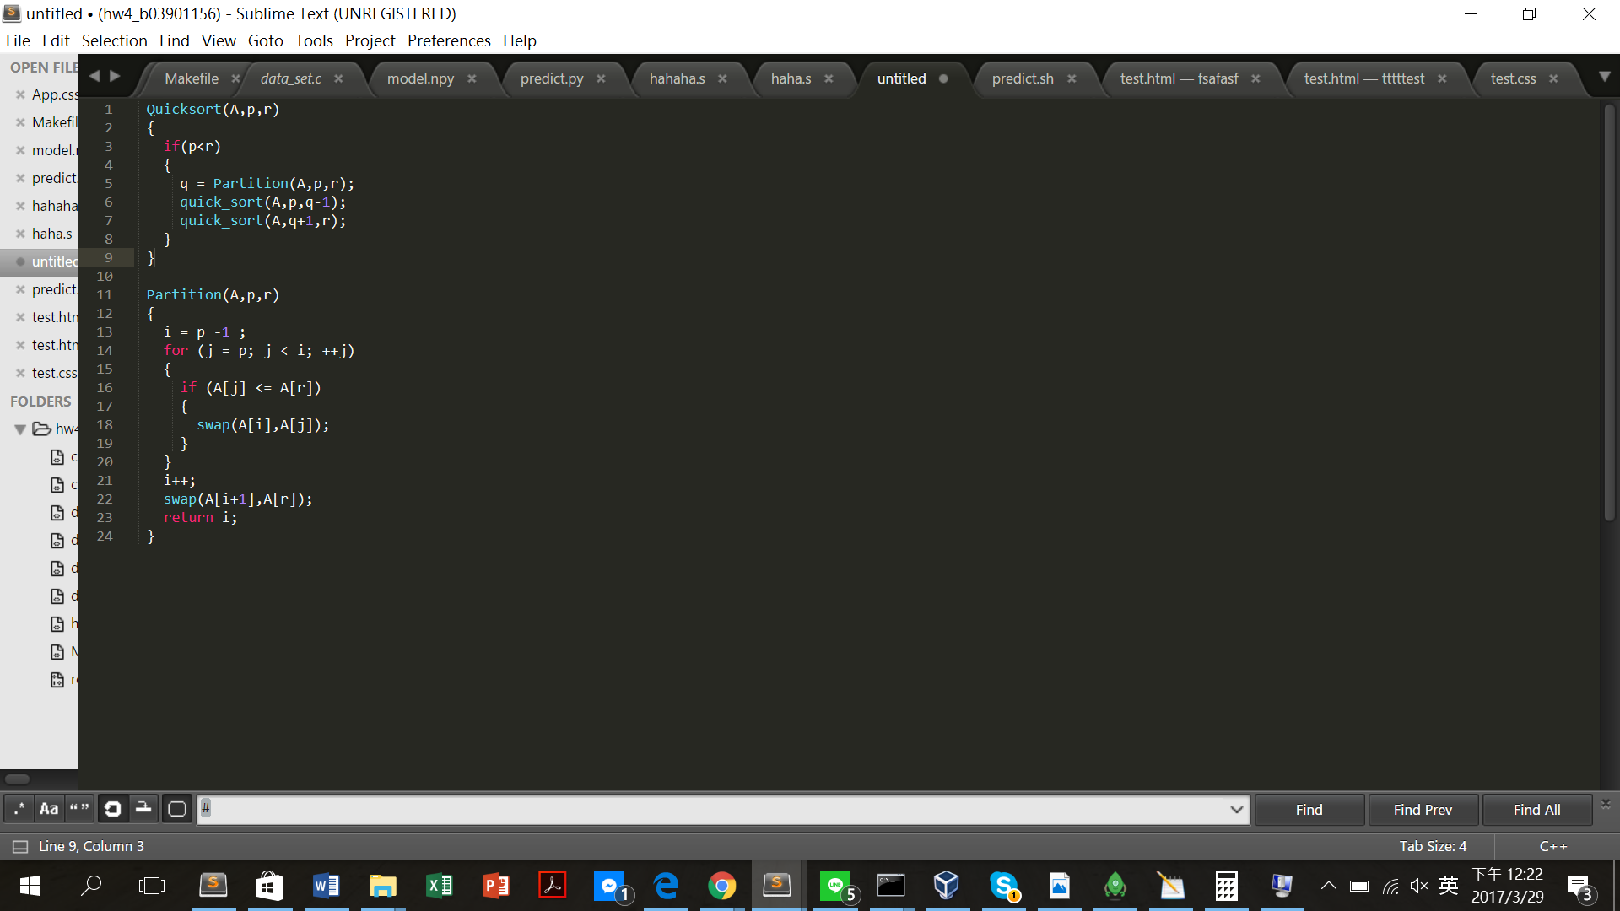

The core of the design is according to the c++ pseudo code on the below:

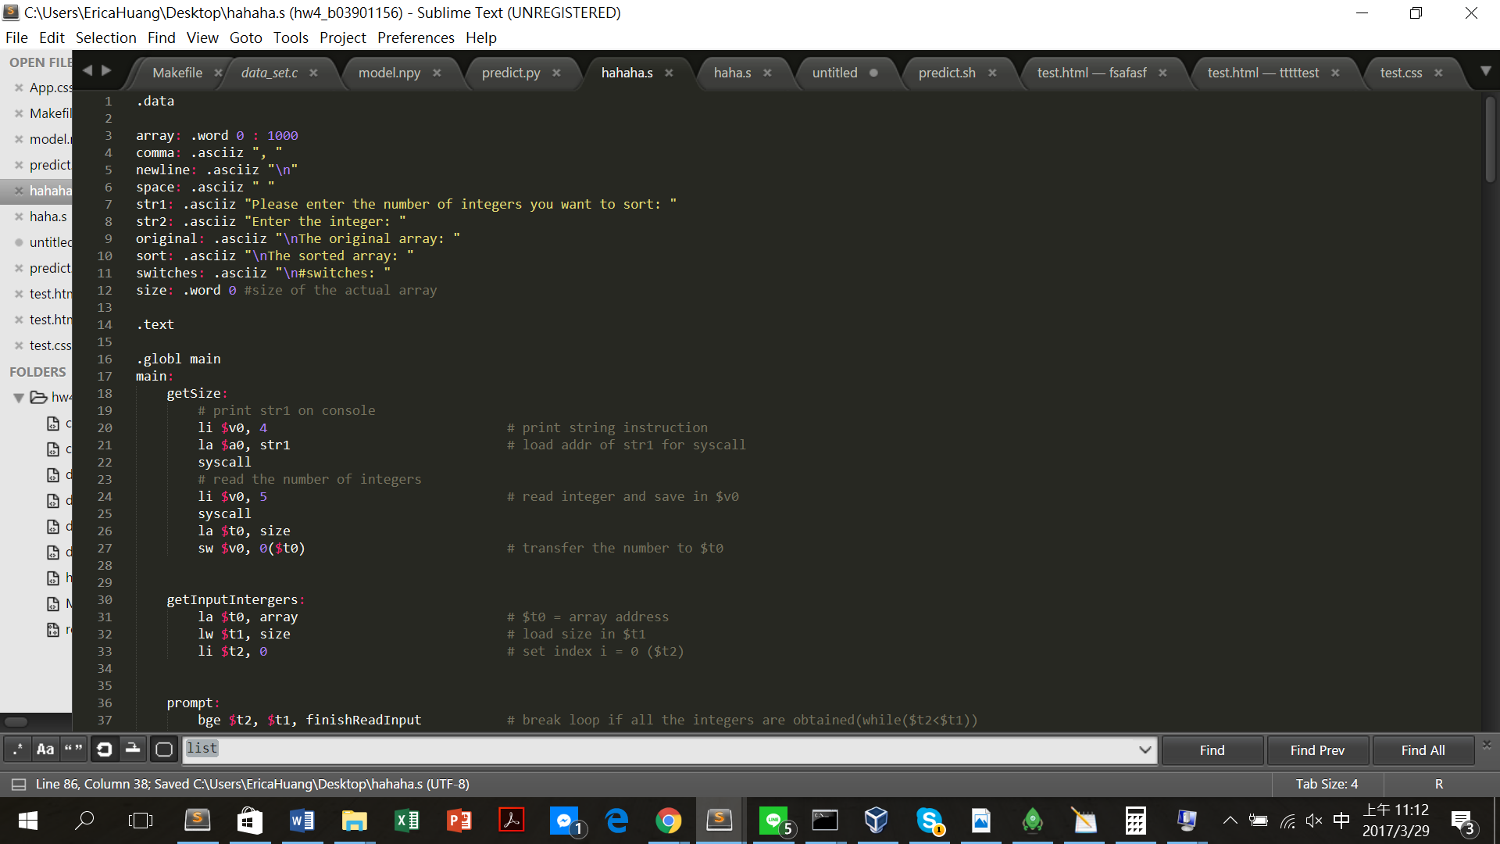

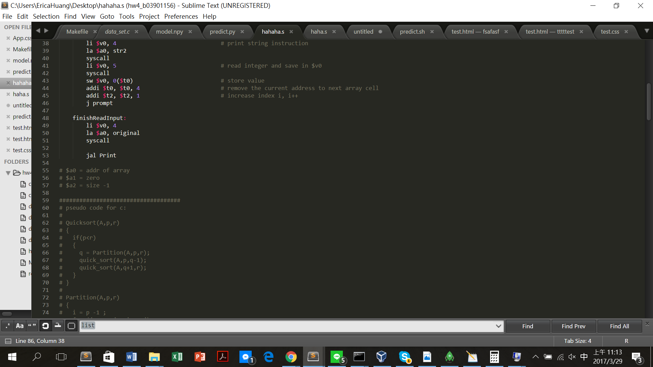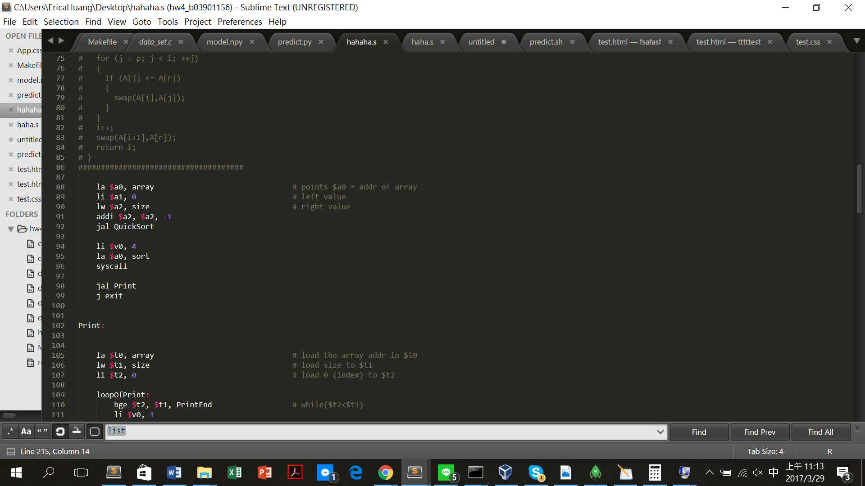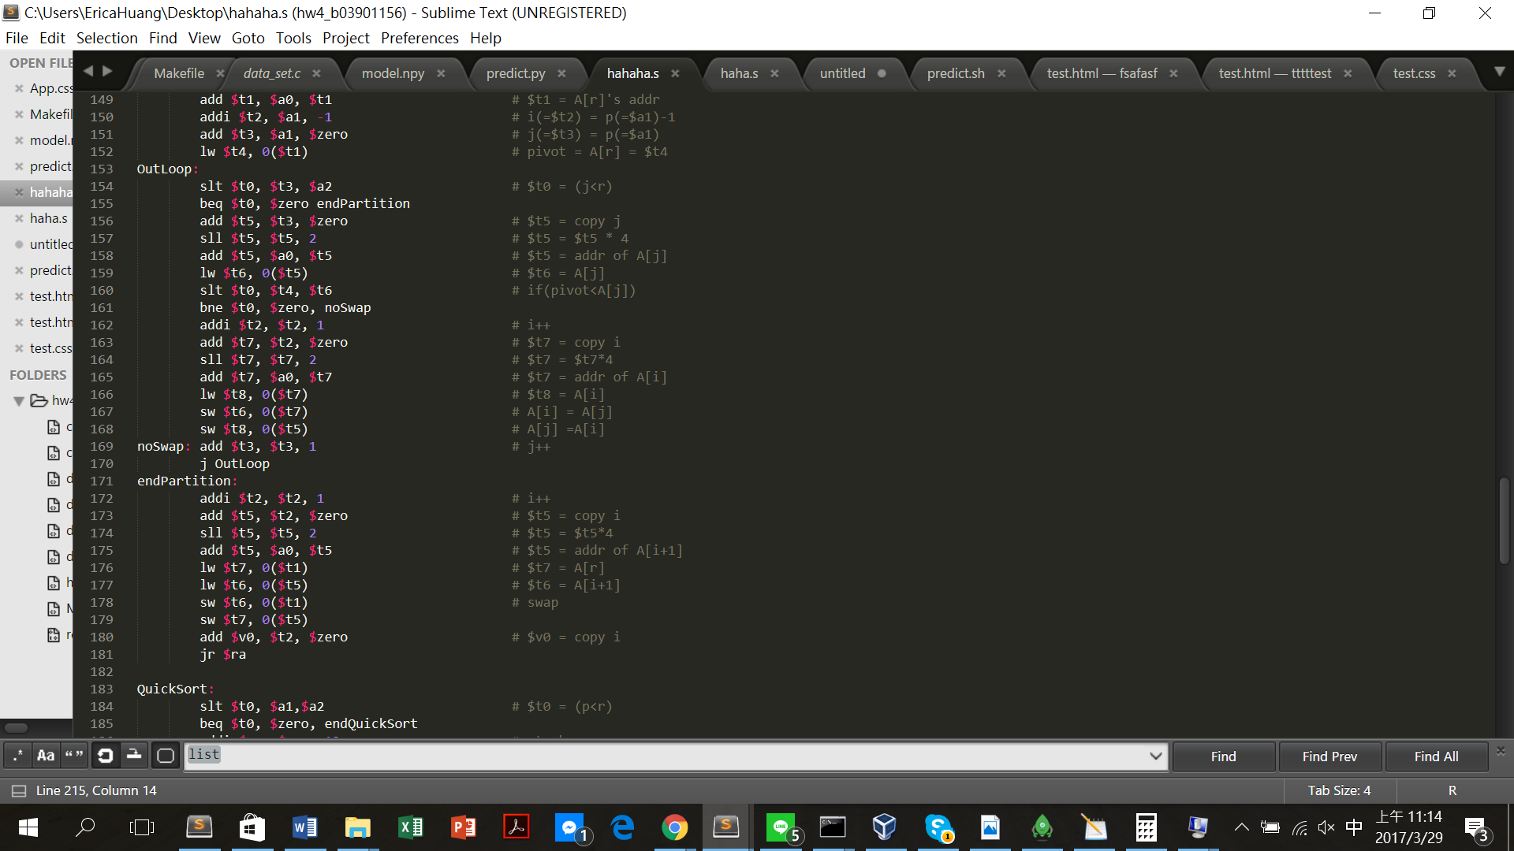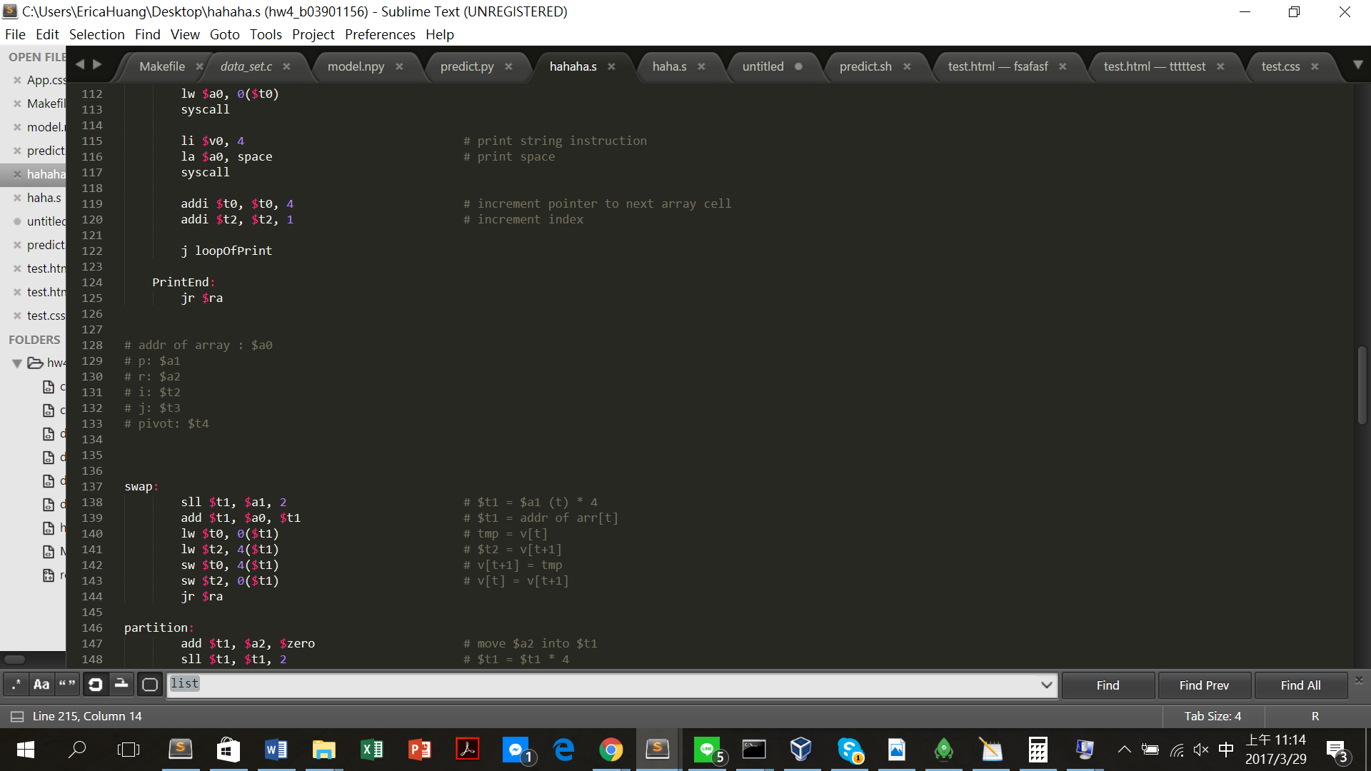

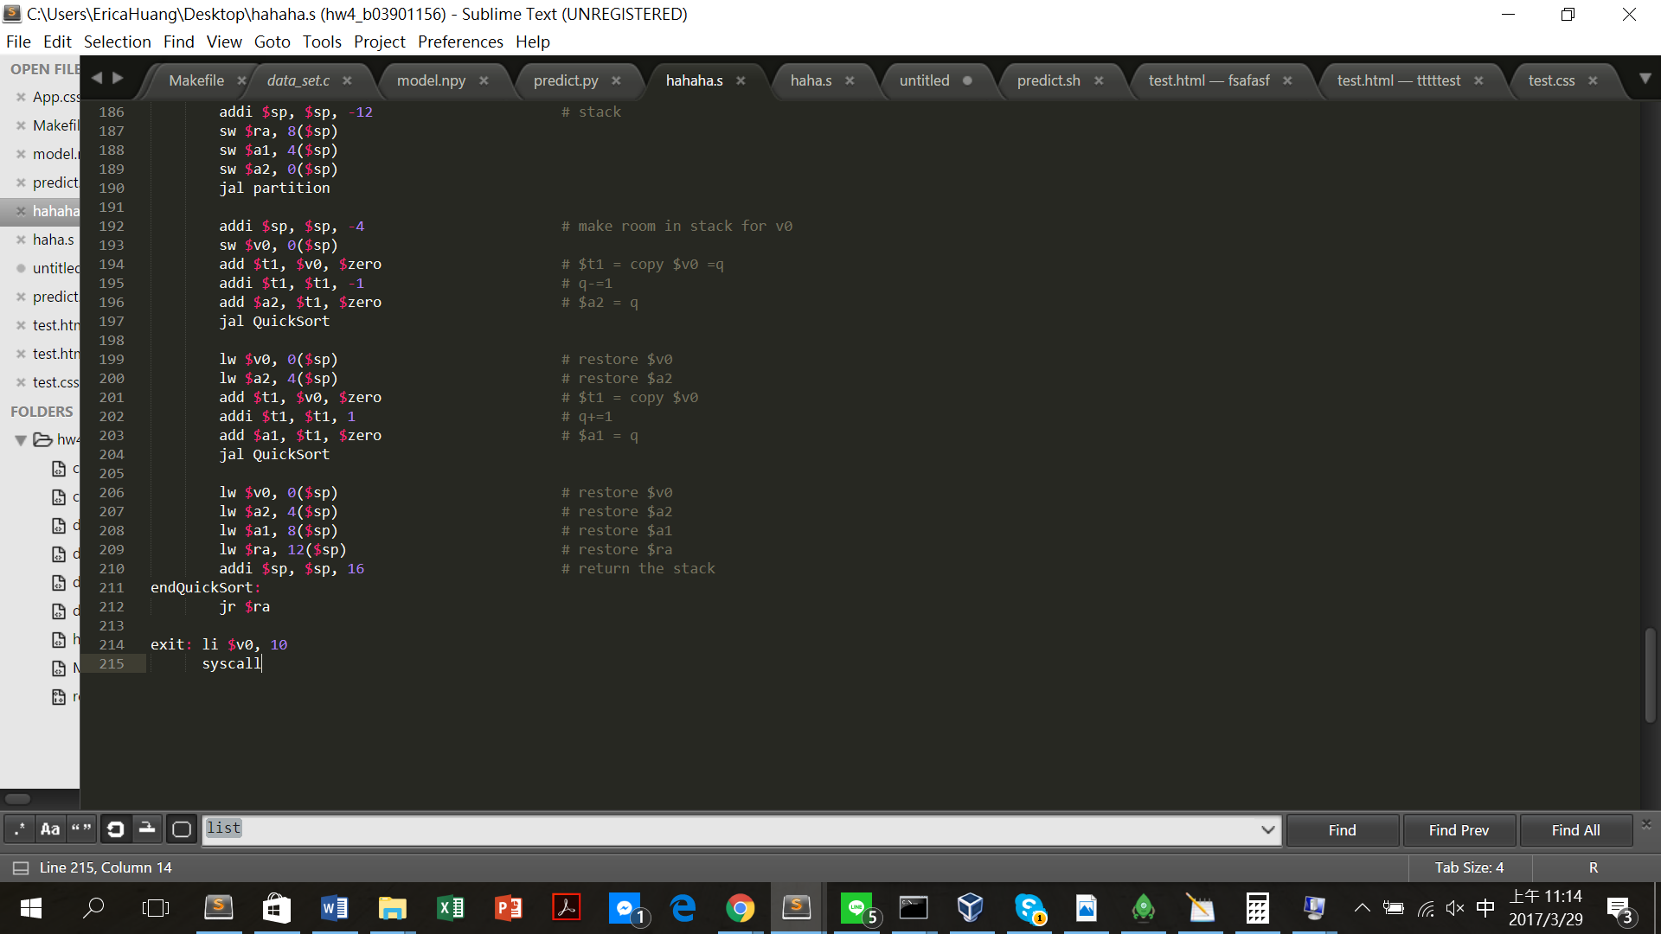

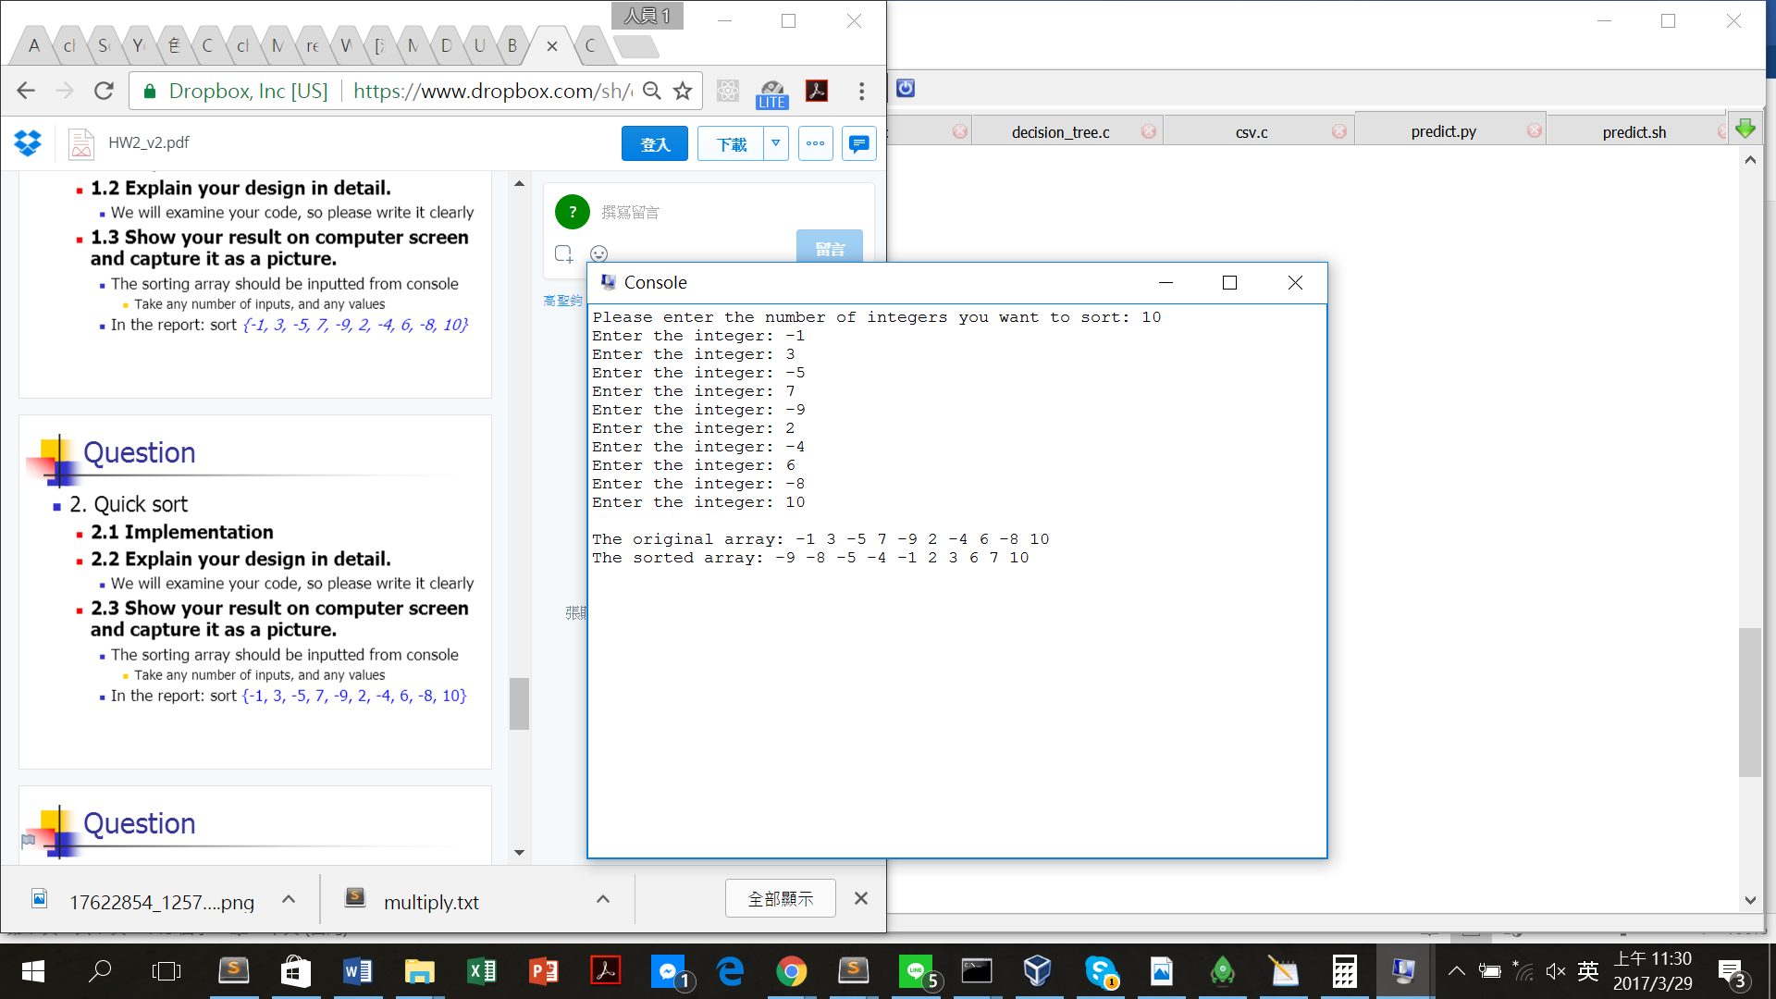Result: